Program Structures and Algorithms

Spring 2023 (SEC—8)

NAME – Abhinav Ankur

NUID – 002747605

**Task** – Parallel Sorting

**Code –**

Array Size – 1 million, 2 million, 3 million

Threads – 2 to 32 (powers of 2)

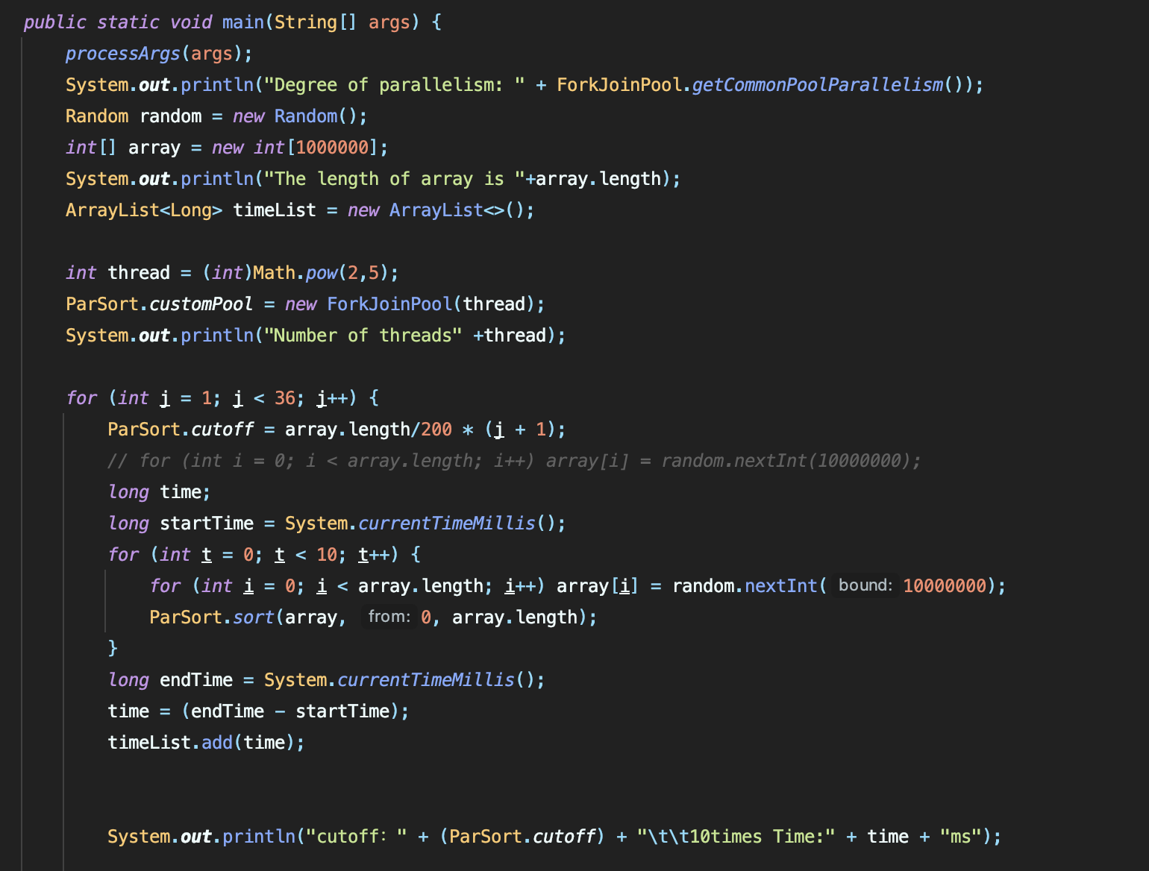

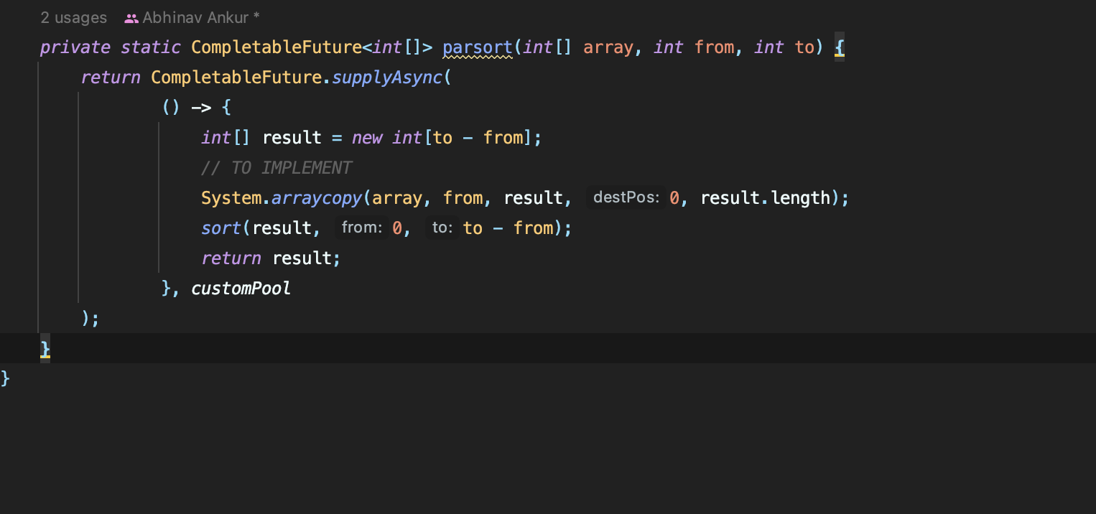

**Observations -**



**Graph –**

Few Examples

Thread- 2

Good Cut-off: 50% of the array size

Thread – 4

Good Cut-off: 25% of the array size

**Conclusion**

The performance is similar when the number of threads is increased.

Good Cut-off – array size/no. of threads